Mesh, Node



|  |  |  |  |  |  |  |  |  |  |
| --- | --- | --- | --- | --- | --- | --- | --- | --- | --- |
|  | R1 | | | R2 | | | R3 | | |
| VR1 | IR1 | PR1 | VR2 | IR2 | PR2 | VR3 | IR3 | PR3 |
| MATLAB | 9.1667V | 41.67mA | 381.9mW | -23.5V | 50mA | 1.175W | -4.167V | 8.333mA | 34.72mW |
| PSPICE | 9.1667V | 41.67mA | 381.9mW | -23.5V | 50mA | 1.175W | -4.167V | 8.333mA | 34.72mW |



|  |  |  |  |  |  |  |  |  |  |
| --- | --- | --- | --- | --- | --- | --- | --- | --- | --- |
|  | R1 | | | R2 | | | R3 | | |
| VR1 | IR1 | PR1 | VR2 | IR2 | PR2 | VR3 | IR3 | PR3 |
| MATLAB | -11.0V | 50mA | 550.0mW | -9.691V | 20.62mA | 199.8mW | -4.167V | 29.38mA | 431.6mW |
| PSPICE | -11.0V | 50mA | 550.0mW | -9.691V | 20.62mA | 199.8mW | -4.167V | 29.38mA | 431.6mW |



|  |  |  |  |  |  |  |  |  |  |
| --- | --- | --- | --- | --- | --- | --- | --- | --- | --- |
|  | R1 | | | R2 | | | R3 | | |
| VR1 | IR1 | PR1 | VR2 | IR2 | PR2 | VR3 | IR3 | PR3 |
| MATLAB | -11.0V | 50mA | 550.0mW | -14.54V | 19.07mA | 449.6mW | -9.536V | 30.93mA | 181.9mW |
| PSPICE | -11.0V | 50mA | 550.0mW | -14.54V | 19.07mA | 449.6mW | -9.536V | 30.93mA | 181.9mW |



|  |  |  |  |  |  |  |
| --- | --- | --- | --- | --- | --- | --- |
| Resister | V | | I | | P | |
| MATLAB | PSPICE | MATLAB | PSPICE | MATLAB | PSPICE |
| R1 | 281.278mV | 0.28V | 28.128mA | 28.13mA | 10.72mW | 10.72mW |
| R2 | 1.261V | 1.26V | 12.610mA | 12.61mA | 17.67mW | 17.67mW |
| R3 | 3.418V | 3.415V | 15.517mA | 15.52mA | 83.25mW | 83.25mW |
| R4 | 10.458V | 10.46V | 10.458mA | 10.46mA | 107.0mW | 107.0mW |
| R5 | 8.3049V | 8.305V | 17.670mA | 17.67mA | 165.6mW | 165.6mW |
| R6 | 2.1528V | 2.155V | 2.1528mA | 2.153mA | 8.704mW | 8.704mW |

Thevenin, Notron



|  |  |  |  |  |  |  |
| --- | --- | --- | --- | --- | --- | --- |
| Resister | V | | I | | P | |
| MATLAB | PSPICE | MATLAB | PSPICE | MATLAB | PSPICE |
| R1 | 1.5792V | 1.579V | 1.759mA | 1.759mA | 3.0947mW | 3.095mW |
| R2 | 1.098V | 1.01V | 2.019mA | 2.02mA | 2.0381mW | 2.038mW |
| R3 | 0.744V | 0.744V | 1.4878mA | 1.488mA | 1.1059mW | 1.106mW |
| R4 | 0.2592V | 0.259V | 259.37uA | 259.4uA | 67.28uW | 67.28uW |
| R5 | 0.531V | 0.53V | 531.32uA | 531.3uA | 282.18uW | 282.2uW |
| R6 | 1.487V | 1.48V | 1.488mA | 1.488mA | 2.2132mW | 2.213mW |

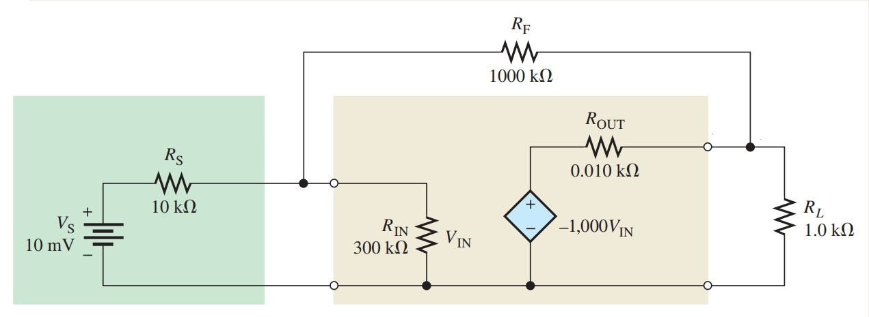



|  |  |  |  |  |  |  |
| --- | --- | --- | --- | --- | --- | --- |
| Resister | V | | I | | P | |
| MATLAB | PSPICE | MATLAB | PSPICE | MATLAB | PSPICE |
| RS | 20uV | 0V | 9.531uA | 9.53uA | 908.38nW | 908.4nW |
| RIN | 9.98mV | 10mV | 284.4nA | 284nA | 24.261nW | 24.26nW |
| RF | -9.815V | -9.82V | 9.816uA | 9.82uA | 96.348uW | 96.35uW |
| Rout | 0.099V | 0.1V | 10.2nA | 0A | 982.21uW | 982.2uW |
| RL | -9.901V | -9.90V | 9.901mA | 9.9mA | 98.025W | 98.03mW |